Name: | ___________________________________________________ |  | Date: ___________
 | Year 10A Mathematics Course  Test 4 , 2015  Topics – Pythagoras and Trigonometry |  | 46  = %
Total Time: | 60 minutes
Total Reading: | 5 minutes
Total Working: | 55 minutes
Weighting: | 5 % of the year.
Equipment Allowed: | 1 page notes (A4 both sides), Scientific calculator
CALCULATOR ASSUMED: Show all working for full marks, place answer in space if provided.

1. | [2 marks]
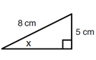
Find the angle x, to 1d.p
 | X=

2. | [2 marks]
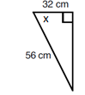
Find the angle x, to 1d.p..
 | X=

3. | [4 marks: 2, 2]
 | Find the side lengths marked x, to 3 significant figures.
a) | 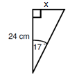 | b) | 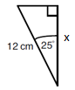
 | X= |  | X=

4. | [4 marks: 2,2]
 | 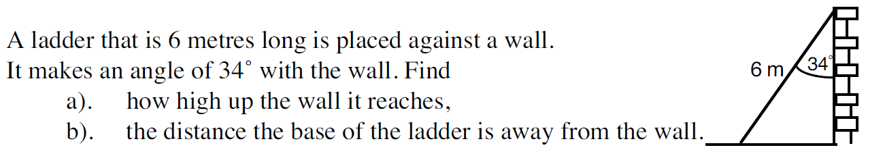
a) |  | Height= |  | (b) | Base distance from wall=

5. | [5 marks: 2, 3.]
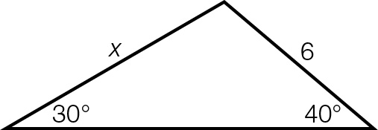
(a) Find the value of x, show working:
 | X=

(b) Find the missing angle and hence find the area.

Angle=______degrees. Area=______units squared.

6. | [10 marks: 1, 1, 2, 2, 2, 2]
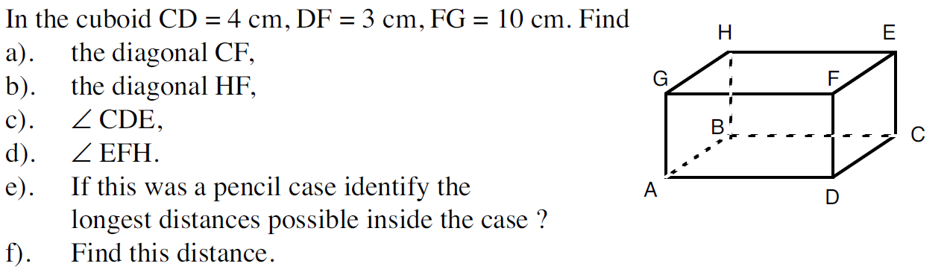
Hence, find the length of the longest pencil which will fit in the case
 | (a) |  |  | (b)
 | (c) |  |  | (d)
 | (e) |  |  | (f)

7. | [6 marks: 4, 2]
A lighthouse 20 m tall, is on top of cliffs 180 m high.
At 9 a.m. the angle of depression of a ship from the top of the lighthouse was 20° and at 9.10 a.m. it was 9°. Draw a diagram of this below, use a straight edge or ruler.

(a) | How many metres did the ship travel away from the cliff in the given time?
(b) | What was the ship’s average speed in km/h? Give your answer to two decimal places.

8. | [5 marks 3, 2.]
If a = 45cm, b = 60cm, and c = 30cm,
(a) What is the value of the smallest angle θ in the triangle ABC.
Give your answer correct to one decimal place. (Hint: you may prefer to draw a diagram)

θ =

(b) What is the area of this triangle ABC, to the nearest square centimetre?

Area=

9. [4 marks 2, 2.]
For the following triangles, find the missing side and hence, or otherwise, find the angle marked θ. (Hint: mark the sides with Hyp, Opp and Adj)

7.2 m
θ
15 m
a)
8.3 m
θ
3.5 m
b)

10. [4 marks 2, 2.]
Using Pythagoras’ Theorem or otherwise, state whether or not the lengths make a right-angled triangle. Show your working.

a) [9, 40, 41]

b) [5, 17, 18]

~ END OF TEST ~

